PE系列 G80万向旋转吊环（G80 Universal Directing rotating Lifting Eyebolt）
执行标准：EN ISO 12100:2010，EN ISO 3266:2010+A1:2015，EN 1677-4:2000+A1:2008
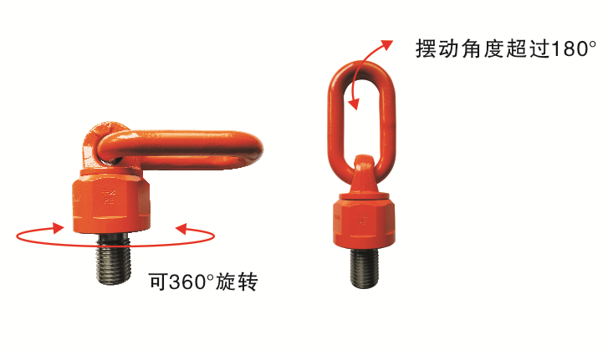
一、产品图示
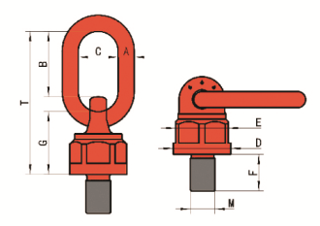
二、产品尺寸表
产品型号 | M | A | B | C | D | E | F | G | T | 重量kg
PE-M8 | M8x1.25 | 13 | 42 | 30 | 40 | 37 | 13 | 44 | 96 | 0.45
PE-M10 | M10x1.5 | 13 | 42 | 30 | 40 | 37 | 17 | 44 | 96 | 0.45
PE-M12 | M12x1.75 | 13 | 42 | 30 | 40 | 37 | 21 | 44 | 96 | 0.46
PE-M16 | M16x2.0 | 13 | 42 | 30 | 40 | 37 | 27 | 44 | 96 | 0.5
PE-M20 | M20x2.5 | 20 | 67 | 40 | 70 | 65 | 33 | 75.5 | 160 | 2.3
PE-M24 | M24x3.0 | 20 | 67 | 40 | 70 | 65 | 40 | 75.5 | 160 | 2.4
PE-M30 | M30x3.5 | 22 | 95 | 51 | 79 | 74 | 50 | 90 | 205 | 3.8
PE-M36 | M36x4.0 | 22 | 95 | 51 | 79 | 74 | 54 | 90 | 205 | 3.9
PE-M42 | M42x4.5 | 26 | 108 | 63 | 93 | 85 | 63 | 100 | 230 | 6.0
PE-M48 | M48x5.0 | 26 | 108 | 63 | 93 | 85 | 68 | 100 | 230 | 6.3
PE-M56 | M56x5.5 | 32 | 120 | 70 | 105 | 95 | 84 | 132 | 278 | 10.8
PE-M64 | M64x6.0 | 32 | 120 | 70 | 105 | 95 | 94 | 132 | 278 | 11.3
PE-M72 | M72x6.0 | 46 | 130 | 90 | 170 | 145 | 108 | 160 | 340 | 31.0
PE-M80 | M80x6.0 | 46 | 130 | 90 | 170 | 145 | 120 | 160 | 340 | 32.0
PE-M90 | M90x6.0 | 46 | 130 | 90 | 170 | 145 | 135 | 160 | 340 | 34.0
PE-M100 | M100x6.0 | 46 | 130 | 90 | 170 | 145 | 135 | 160 | 340 | 36.5

三、起吊方式及载荷表
起吊方式 |  | 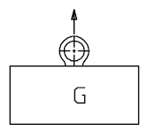 | 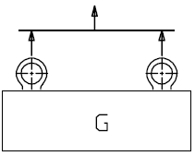 | 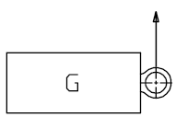 | 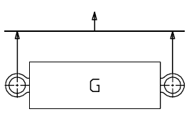 | 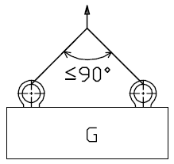 | 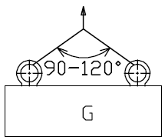 | 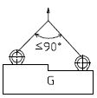 | 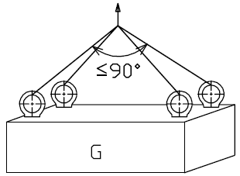 | 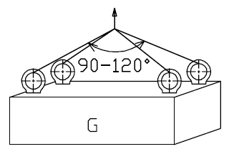 | 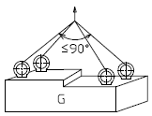
吊点数量 |  | 1 | 2 | 1 | 2 | 2 | 2 | 2 | 3-4 | 3-4 | 3-4
起吊角度 |  | 0° | 0° | 90° | 90° | ≤90° | 90-120° | ≤90° | ≤90° | 90-120° | ≤90°
产品型号 | 螺纹规格（mm） | 工作拉力（工作安全极限载荷WLL）t
PE-M8 | M8x1.25 | 0.6 | 1.2 | 0.3 | 0.6 | 0.4 | 0.3 | 0.3 | 0.6 | 0.4 | 0.3
PE-M10 | M10x1.5 | 0.9 | 1.8 | 0.45 | 0.9 | 0.6 | 0.4 | 0.4 | 0.9 | 0.6 | 0.4
PE-M12 | M12x1.75 | 1.1 | 2.2 | 0.55 | 1.1 | 0.77 | 0.55 | 0.55 | 1.1 | 0.83 | 0.55
PE-M16 | M16x2.0 | 2.4 | 4.8 | 1.2 | 2.4 | 1.68 | 1.2 | 1.2 | 2.4 | 1.8 | 1.2
PE-M20 | M20x2.5 | 3.8 | 7.6 | 1.9 | 3.8 | 2.66 | 1.9 | 1.9 | 3.8 | 2.85 | 1.9
PE-M24 | M24x3.0 | 6.4 | 12.8 | 3.2 | 6.4 | 4.48 | 3.2 | 3.2 | 6.4 | 4.8 | 3.2
PE-M30 | M30x3.5 | 9 | 18 | 4.5 | 9 | 6.3 | 4.5 | 4.5 | 9 | 6.75 | 4.5
PE-M36 | M36x4.0 | 13 | 26 | 7 | 14 | 9.8 | 7 | 7 | 14 | 10.5 | 7
PE-M42 | M42x4.5 | 15 | 30 | 10 | 20 | 14 | 10 | 10 | 20 | 15 | 10
PE-M48 | M48x5.0 | 17 | 34 | 12 | 24 | 16.8 | 12 | 12 | 24 | 18 | 12
PE-M56 | M56x5.5 | 26 | 52 | 15 | 30 | 21 | 15 | 15 | 30 | 22.5 | 15
PE-M64 | M64x6.0 | 26 | 52 | 15 | 30 | 21 | 15 | 15 | 30 | 22.5 | 15
PE-M72 | M72x6.0 | 40 | 80 | 25 | 50 | 35 | 25 | 25 | 50 | 37.5 | 25
PE-M80 | M80x6.0 | 43 | 86 | 30 | 60 | 42 | 30 | 30 | 60 | 45 | 30
PE-M90 | M90x6.0 | 45 | 90 | 35 | 70 | 49 | 35 | 35 | 70 | 52.5 | 35
PE-M100 | M100x6.0 | 50 | 100 | 40 | 80 | 56 | 40 | 40 | 80 | 60 | 40
- 所有起吊方向均为4倍安全系数
上表仅适用于一下情况：
--螺纹孔有足够的长度确保螺丝杆全部旋入；
--螺丝牢牢固定，与接触面贴合（用手动旋入，不允许使用工具加力扳紧）；
--设备材料能够承受压力，不会变形，导致安全隐患。
更详细的操作规程见相应的操作使用说明书。
